6.Audit S3 Buckets for Public Access and Notify
Objective: Detect any bucket that is publicly accessible and alert via SNS.

Step 1 – Create an SNS Topic
- Open Amazon SNS.
- Select Topics.
- Click Create Topic.
Configure:
Setting | Value
Type | Standard
Name | S3SecurityAlerts
Click Create Topic.
Example Topic ARN:
arn:aws:sns:us-east-1:206226812351:S3SecurityAlerts
Step 2 – Subscribe Your Email
Open the SNS topic.
Click Create Subscription.
Configure:
Setting | Value
Protocol | Email
Endpoint | your-email@example.com
Click Create Subscription.
Confirm the subscription from your email. 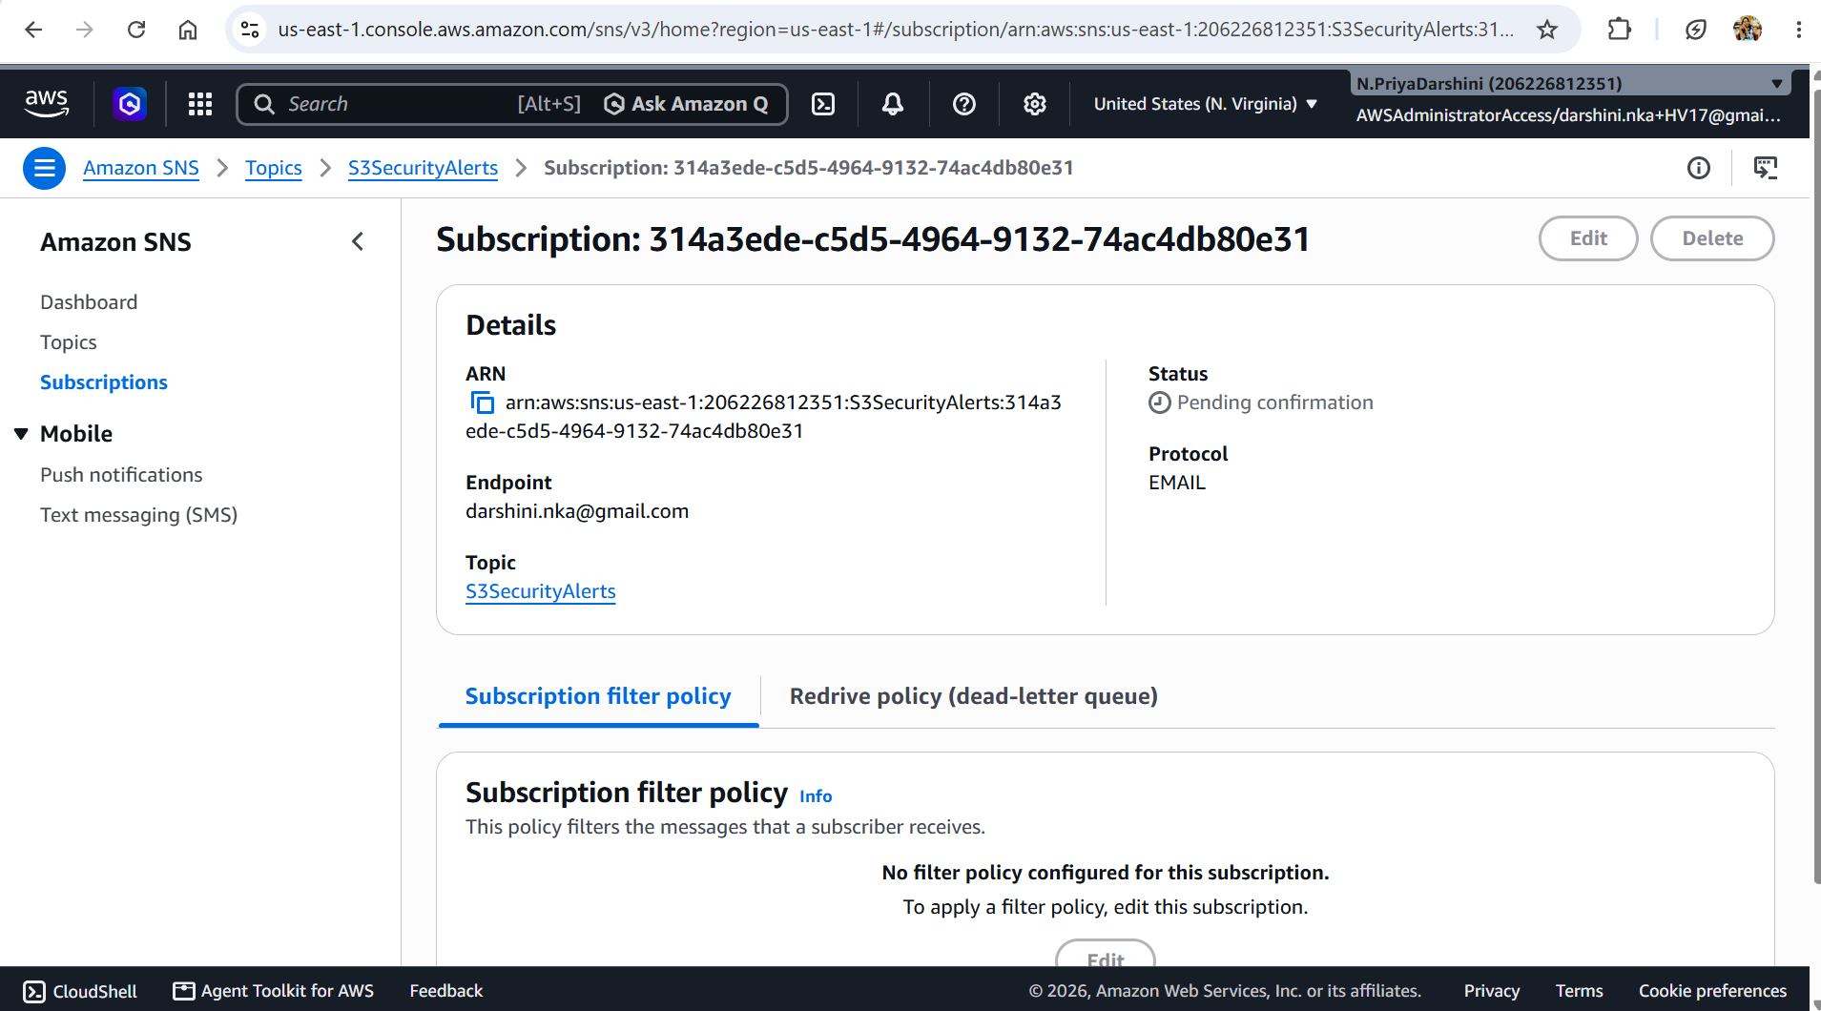

Step 3 – Create IAM Role for Lambda
Navigate to:
IAM
→ Roles
→ Create Role
Choose:
- Trusted Entity: AWS Service
- Use Case: Lambda
Role Name:
S3PublicAuditLambdaRole

Step 4 – Attach CloudWatch Policy
Attach the managed policy:
AWSLambdaBasicExecutionRole

Step 5 – Add Inline IAM Policy
Go to:
Permissions
→ Add Inline Policy
→ JSON
Replace the SNS topic ARN with your own.
{
"Version": "2012-10-17",
"Statement": [
{
"Sid": "S3AuditPermissions",
"Effect": "Allow",
"Action": [
"s3:ListAllMyBuckets",
"s3:GetBucketPublicAccessBlock",
"s3:GetBucketPolicyStatus",
"s3:GetBucketAcl"
],
"Resource": "*"
},
{
"Sid": "SNSPublish",
"Effect": "Allow",
"Action": "sns:Publish",
"Resource": "arn:aws:sns:us-east-1:123456789012:S3SecurityAlerts"
}
]
}

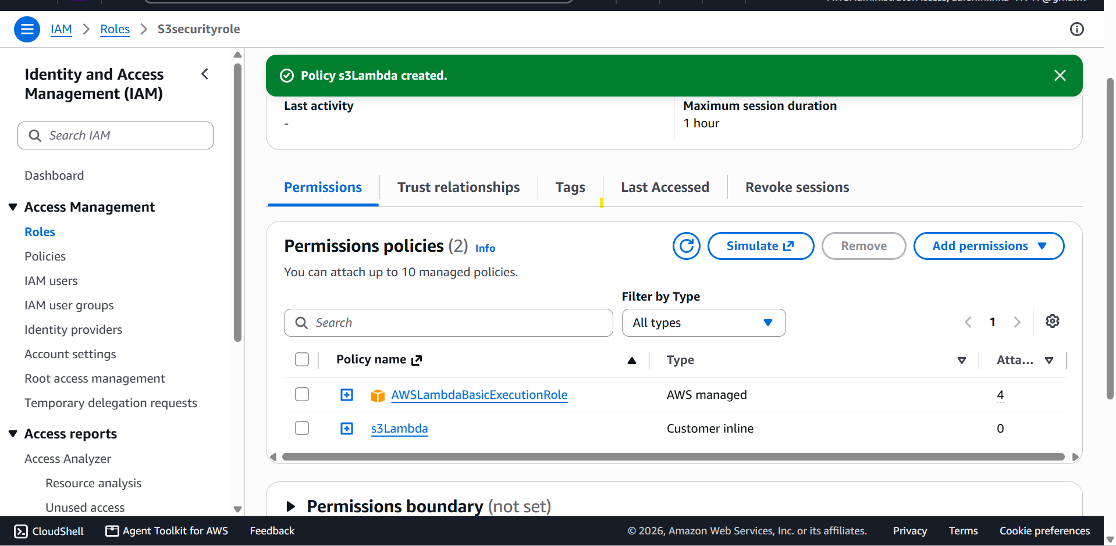

Step 6 – Create Lambda Function
Navigate to:
AWS Lambda
→ Create Function
Configuration:
Setting | Value
Function Name | S3PublicAccessAudit
Runtime | Python 3.12
Execution Role | S3PublicAuditLambdaRole

Step 7 – Configure Environment Variables
Add the following environment variable:
Variable | Example
SNS_TOPIC_ARN | arn:aws:sns:us-east-1:123456789012:S3SecurityAlerts

Step 8 – Lambda Function (Python 3.12)
import os
import boto3
from botocore.exceptions import ClientError

s3 = boto3.client("s3")
sns = boto3.client("sns")

SNS_TOPIC_ARN = os.environ["SNS_TOPIC_ARN"]

def lambda_handler(event, context):

buckets = s3.list_buckets()["Buckets"]

public_buckets = []

for bucket in buckets:

bucket_name = bucket["Name"]

block_public = "Unknown"
policy_public = False
acl_public = False

# Check Block Public Access
try:
response = s3.get_public_access_block(
Bucket=bucket_name
)

config = response["PublicAccessBlockConfiguration"]

block_public = all(config.values())

except ClientError:
# No Block Public Access configuration
block_public = False

# Check Bucket Policy Status
try:
response = s3.get_bucket_policy_status(
Bucket=bucket_name
)

policy_public = response["PolicyStatus"]["IsPublic"]

except ClientError:
policy_public = False

# Check Bucket ACL (legacy)
try:
acl = s3.get_bucket_acl(Bucket=bucket_name)

for grant in acl["Grants"]:

grantee = grant.get("Grantee", {})

uri = grantee.get("URI", "")

if "AllUsers" in uri or "AuthenticatedUsers" in uri:
acl_public = True

except ClientError:
pass

if (not block_public) or policy_public or acl_public:

public_buckets.append(bucket_name)

print(f"Public Bucket Found: {bucket_name}")

if public_buckets:

message = "Public S3 Bucket(s) Detected\n\n"

message += "\n".join(public_buckets)

sns.publish(
TopicArn=SNS_TOPIC_ARN,
Subject="S3 Public Access Alert",
Message=message
)

print("SNS Alert Sent")

else:

print("No Public Buckets Found")

return {
"PublicBuckets": public_buckets
}

Step 9 – Deploy the Lambda
Click Deploy.

Step 10 – Create a Test Event
Create a test event:
{}
Run the Lambda once to confirm it executes successfully.

Status: Succeeded
Test Event Name: TestEvent

Response:
{
"PublicBuckets": []
}

Step 11 – Configure EventBridge Schedule
Navigate to:
Amazon EventBridge
→ Rules
→ Create Rule
Configure:
Setting | Value
Rule Name | DailyS3SecurityAudit
Rule Type | Schedule
Use one of the following schedules:
Cron Expression
cron(0 8 * * ? *)
(Runs daily at 08:00 UTC)
OR
rate(1 day)
Target:
Lambda Function

S3PublicAccessAudit
Click Create Rule.
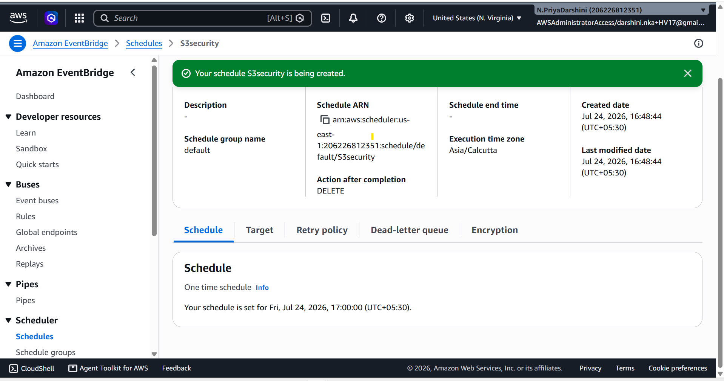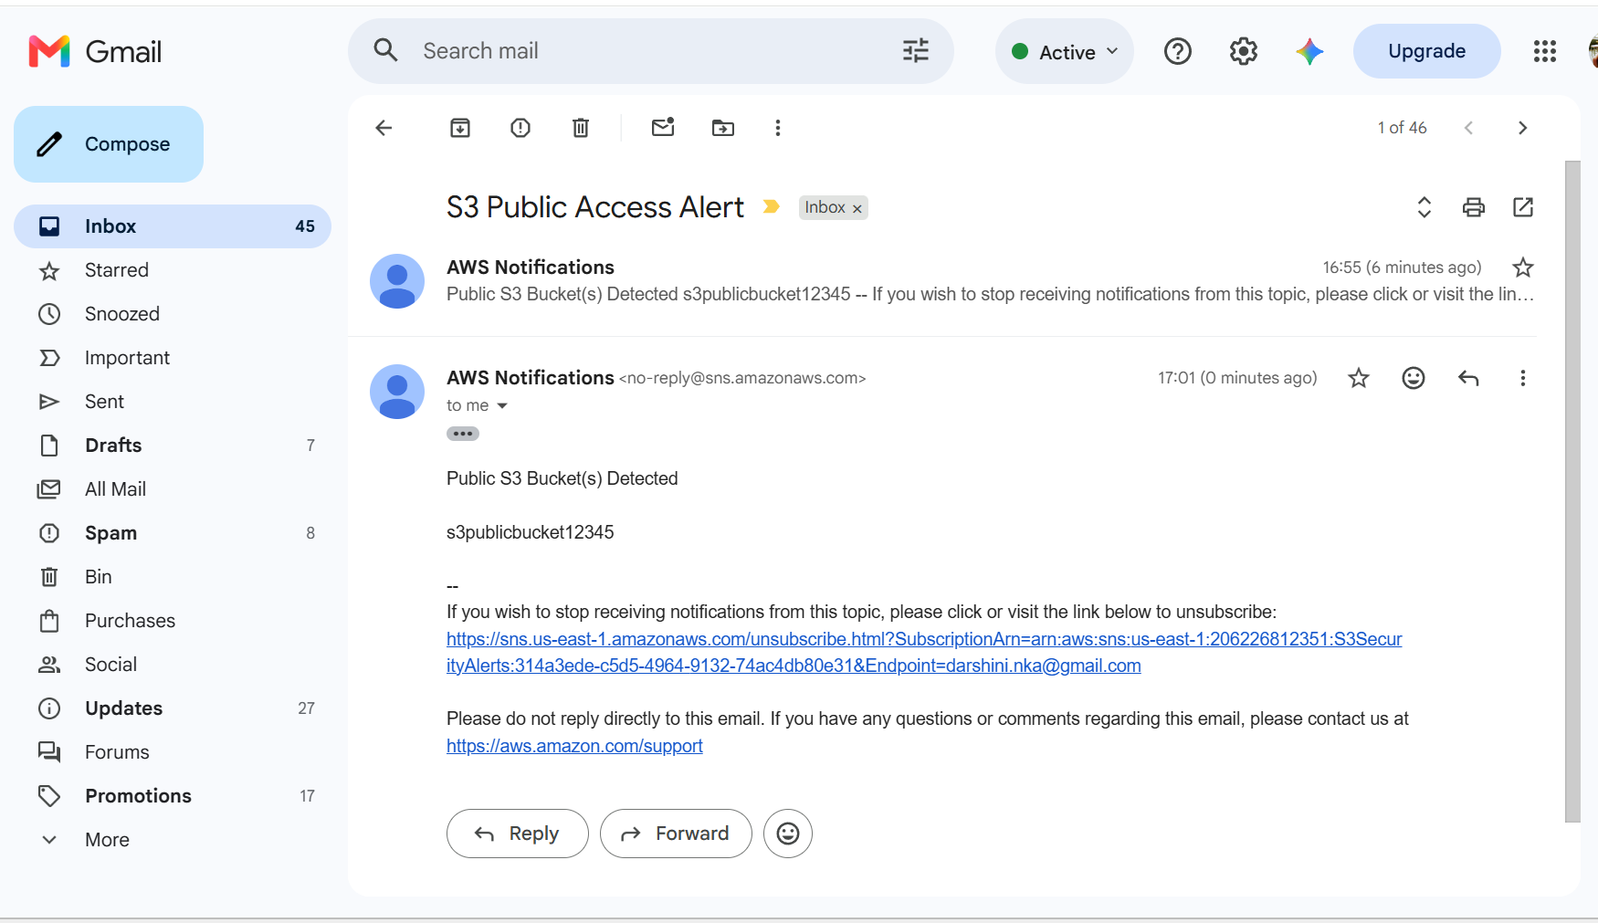

Step 12 – Testing
Create a dedicated test bucket (never use a production bucket).
- Disable Block Public Access for the test bucket.
- Attach a temporary public-read bucket policy, for example:
{
"Version": "2012-10-17",
"Statement": [
{
"Sid": "PublicRead",
"Effect": "Allow",
"Principal": "*",
"Action": "s3:GetObject",
"Resource": "arn:aws:s3:::your-test-bucket/*"
}
]
}
- Run the Lambda manually.
Expected results:
- The Lambda detects the bucket.
- The bucket name appears in the CloudWatch logs.
- An SNS email is sent identifying the public bucket.
Important: Immediately remove the public bucket policy and re-enable Block Public Access after testing. 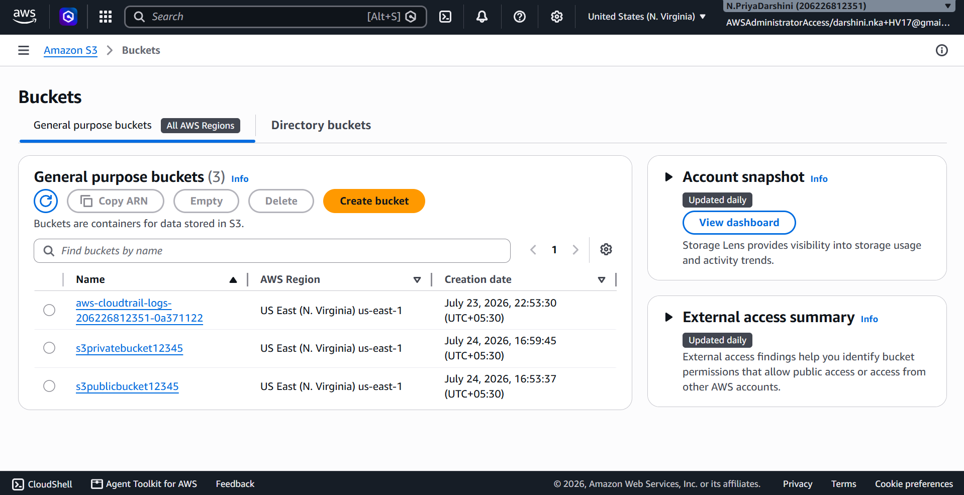 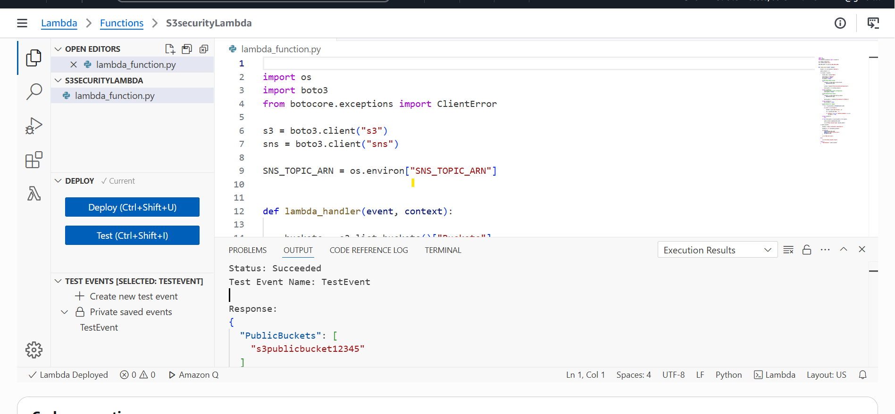

Step 13 – Verify CloudWatch Logs
Open:
CloudWatch
→ Log Groups
→ /aws/lambda/S3PublicAccessAudit
Example:
Public Bucket Found: my-test-public-bucket

SNS Alert Sent

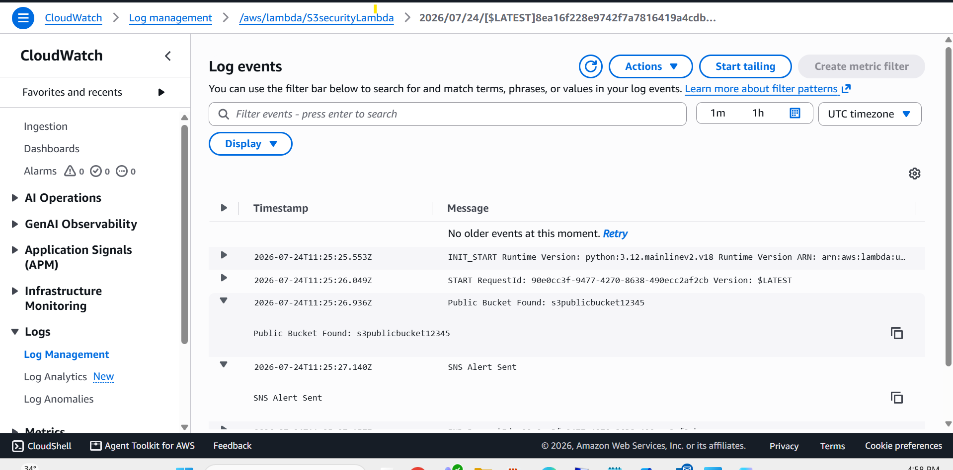

Step 14 – Verify SNS Email
Example email:
Subject
S3 Public Access Alert
Body
Public S3 Bucket(s) Detected

my-test-public-bucket 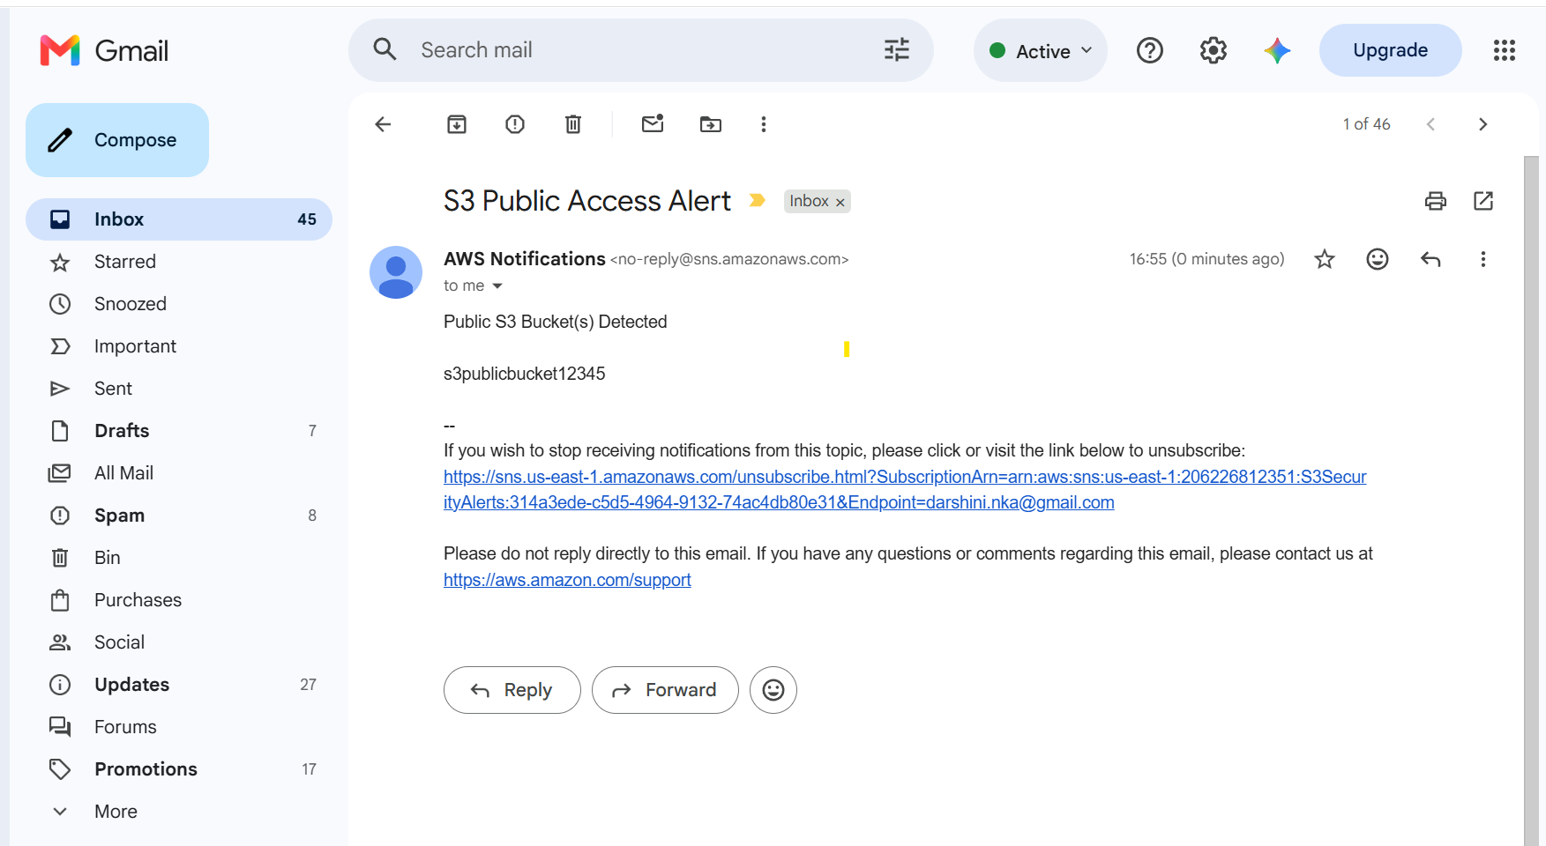

Discussion Point (Interview Answer)
For continuous S3 security posture management, AWS Config (for example, the managed rule s3-bucket-public-read-prohibited) and Amazon S3 Block Public Access provide native governance and compliance capabilities.
A Lambda-based solution is preferable when you need custom security logic, such as sending notifications to Slack or Microsoft Teams, applying organization-specific exceptions, integrating with ticketing systems, or performing automated remediation (for example, re-enabling Block Public Access or removing public bucket policies automatically).

